Possible Grading System Bug – DS-4: Supervised Learning I – Regression Foundations
Dear ALX Support Team,
I am experiencing what appears to be a possible issue with the automated grading system for the DS-4: Supervised Learning I – Regression Foundations, Module 1 project.
Every time I submit my project, the grading system returns the following error:
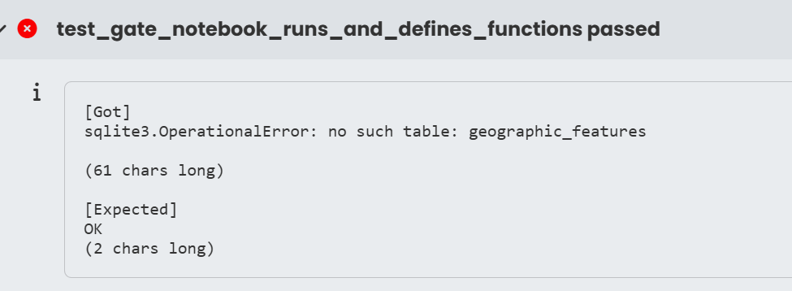
This error has occurred on every submission I have made for this project, including submissions where the code runs correctly in my local environment and the required outputs are produced as expected.
The error specifically indicates that the grading environment is unable to find the geographic_features table in the SQLite database. This makes me suspect that there may be an issue with the grading environment, database setup, or the test configuration rather than with the submitted solution.
Could you please investigate the grading system and confirm whether the SQLite database and its required tables, particularly geographic_features, are correctly configured and accessible to the automated tests?
I would appreciate it if you could investigate this as it is preventing me from receiving a valid grade for the project despite repeatedly submitting my work.
Thank you for your assistance.
Kind regards,
Thomas Oluwasegun Olubunmi
Email: to.olubunmi@gmail.com
Data Science track ( self-paced)

